Be in a Transitional Mode Permanently and Find Your Inspiring Job
Joana Visa PhD, ACC, CAE, CPTC
Coach and Founder
35+Executive Women Coach
October 2019

Are you in control of your life and have room for ‘me time’? Can you say that you grow and learn every day? Do you have a strong network? Are you visible? Can you cope with gender-fair situations and lead amazing projects? Do you have an inspiriting job? My answer to all of these is a big yes, and I would like to share my insights with you.
If only 20% of the wealthy people in their 50s are unhappy with their lives, do you want to be one of them?

At School
Reflecting on my childhood in Barcelona, (I was born in 1966)and during my teenage years I worked and studied harder, it was my only path to freedom. I was born in a family with three brothers and I did not fit. I understood fast that the main rule in our home was simple: if your reports at the school are good, you can do as you wish. I got it. I decided that I will have a very good report and then I will be able to choose and do what I please. It was a nice plan, but what I would learn next is that ‘ladies’ don’t get the same rules. I realised that despite always having better reports than my brothers, I still had to behave like a ‘lady.’ I still couldn’t make the same choices as them.

At the University
In 1984, at the age of 17, it was time for me to decide the course I was going to get my degree in. I chose the Veterinarian school. Why? Because in the year that I chose it, there were no Veterinary schools in Barcelona and I would have to move 400 km away. Fantastic. I ‘had to’ move to another city, meet people, be on my own, and do as I wish.
The decision was made. I would ‘have to’ go to the North of Spain to attend Veterinarian School. But, alas, it was not to be. The year before I applied, a new veterinarian school was built in Barcelona, only 25 km away from my home. Only 25 km! And I have to stay at home. For five years I studied harder. It was my only path to freedom.
First Jump: Biomedical Research
I applied to do my PhD in the same veterinarian school I studied. A topic for my thesis was decided (Parasitic illness in dogs) but after a year my PhD director called me to his office :he wanted me to change not only the topic of my thesis but also my PhD director. I said yes. I most probably did not even have another option, but I didn't really care. I wanted to take the risk, so I said that it would be great. and offer to move another topic:
The average time needed for doing a thesis is about 5 or 6 years, I did in 4. I defended my thesis in 1994.
My first son decided to be born one month before his time, so I defended my thesis just after I gave birth. I had three kids in three years. Even while raising small children, I still was hungry for knowledge, and I needed more. After my second child was born, my contract expired and it was not renewed. I stayed, against my will, without a job for 6 months. What did I do? I enrolled in a university for a six months program related to safety and public health. I did not like it. This was not what I wanted. After these six months, I was hired again.
I wanted to do more biomedical research. My goal was to climb further in my professional career. I wanted to explore science.
Second Jump: Managerial Role
Next to my office, at the Veterinarian School, there was another door. Have you seen the movie Monster Inc.? If you’ve seen it, there is this place where thousands of doors are waiting to be opened for Sullivan, the huge monster, to open each door and scare the children. I had the same experience: I opened this door, and I met my mentor.
I went to the Netherlands to have a formal education on animal welfare specialist. and applied for a new job: to be a veterinarian in charge of an animal facility in a Cancer Institute. I jumped my professional curve again. This was the first time that I had some managerial responsibilities. I had to manage a team and I had to manage the researcher, too. I loved it. First, I got my new credentials; then I got my new job. Learn and jump. Learn and jump.
I began to build my “value model”. How can I jump frequently? I had to be in a transitional mode permanently. I wanted to be part of the community of freelance women. I realised that what I need is to follow some basic steps: build my foundation (who I am and What I want), accelerate my progress (networking, visibility, unleash my potential) , and then jump to find a job that inspires me.
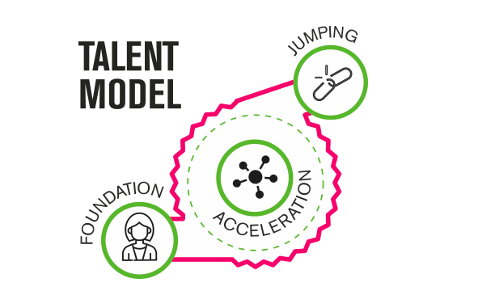
Third Jump: Executive
When I was around 40, At this time, I felt the need to move in the direction of quality assessment and legal compliance, so I got my third masters in Master of Quality Management. I had acquired new knowledge; a new door was ready to be opened was offered the position of the Quality Director of my Biomedical Institute.
Fourth Jump: Entrepreneur
My kids were young adults and were still living with me; I was happy with this. In fact, I was more than happy.
It was 2016, when I was attending and executive master I .
In Brussels, when I was getting my master’s degree to improve my executive skills, I met a German lady who lived there and worked for a non-profit association.

"Do you know what is a coach, Joana?" She said. Subsequently, we built a coaching company together in 2017. I become an entrepreneur when I had crossed 50.
This is where I am now. At the second launch of our coaching company.
I feel proud of the kind of life that I have built. I jumped the curve several times. I am a freelancer and I am a woman. I have been always in a transitional mode to find my inspiriting job.
I am still applying my own model: I will keep my life balanced, look for new challenges, look for new connections, lead outstanding projects, and find an inspiriting job. If the job that I find is not exciting enough, I will look for new knowledge and begin to look for a new job again. Before I retire, I will jump again. I do not know what I am going to do, but I know how. A new learning is waiting for me. Another door is waiting to be opened by me.

Final Words
I want my story to inspire you and give you tools and tips that you can apply in your own life to take your career to the next level. Here’s to you finding your inspiriting job!
As for me, I am always ready to learn, grow, and jump.

My Contact Details

Joana Visa PhD, CAE, ACC
Coach, Founder
35+Executive Women Coaching
joanavisa@35ewc.com
in/joanavisacoaching/
35executivewomencoaching

My bio

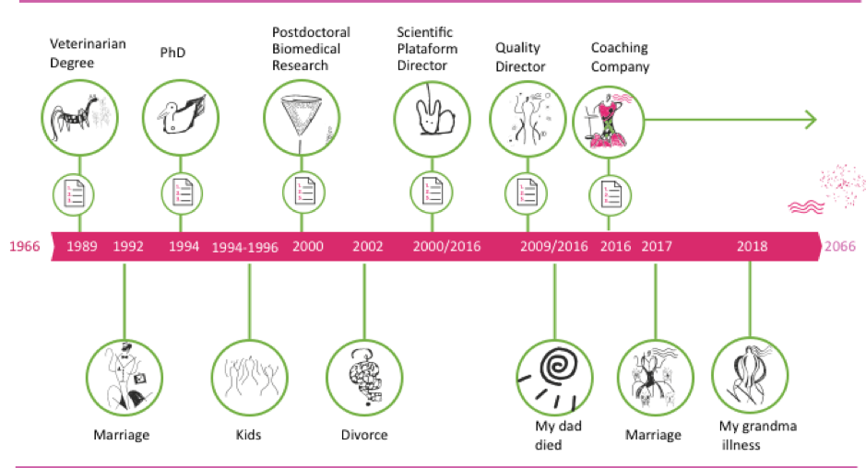

If you are willing to take your career to the next level, if you want to take the fast track to the top, if you are an executive woman who wants to jump the innovation curve, then Joana Visa can definitively help you.
She is an internationally certified coach who delights in empowering women so they can become senior executives and impact the world. Joana has accelerated young, talented women by guiding them into a new dimension of their selves. Her passion is sharing her own experience as a scientist, as a teacher, and as an executive to launch women into the arena, like the gladiators in Roman Coliseum. She believes that by working with their clients’ strengths, every woman can have her 'me time' and a balanced life so they can grow and learn every day, be visible, lead amazing projects, and finally find an inspiriting job.
You can walk this path alone, spend a huge amount of time, or walk in a partnership with Joana and go faster. If you have a clear purpose in your life, you will be able to see the path. Joana will be there with you. Don’t go alone. Go with Joana.

My picture

